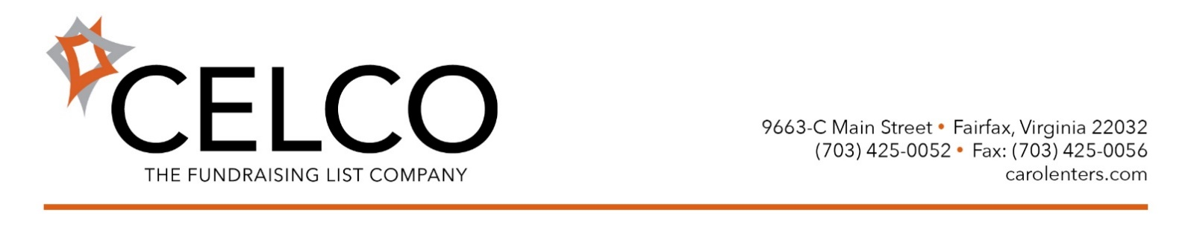
The New Normal for Direct Mail Acquisition - Looking Good
Dottie Parham
Vice President
CELCO
Nonprofits are typically mailing more acquisition quantity, as investment and ROI get back on track from the difficult recession years.
Recently, we looked at our top 40 clients who mail 102,000,000+ acquisition pieces annually. In 2017 results vary from sector to sector but, overall, we saw clients mailing, on average, 10% more than in 2016. The cost to mail and cost to acquire stayed about the same. We see a slight dip in response but a critical improvement to offset that factor - a whopping 16% lift in average gift.
What is creating this New Normal when the old normal for all sectors used to be largely “flat?”
From the list standpoint, our databases are far more sophisticated. We target higher-dollar lists and select based on initial gift, as well as predicted timing and value for ROI. We use custom models—a lot. With client and vendor partners, we work to best utilize exchanges, optimize files, and rotate lists and packages to maximize efficiencies. We also negotiate lower costs.
True, not all results have improved. We’ve seen groups struggle to fundraising in areas where donors are struggling themselves with man and natural made disasters – fires, floods, hurricanes, both national and international. Some relief groups have seen an influx of donors wanting to help.
Over many years, we have seen stellar results for Animals, Seniors, and Health groups. We’ve seen sectors—Advocacy and Environmental in particular—show enormous improvement in the months since President Trump got elected. In 2018, some will continue to benefit from the chaotic political climate but most are working to improve their core, mission based acquisition programs.
Today, acquisition looks good and, with data-driven planning, should continue to improve.
Tomorrow? Let’s just say that would be like trying to predict “who tweets what” on any given day.

